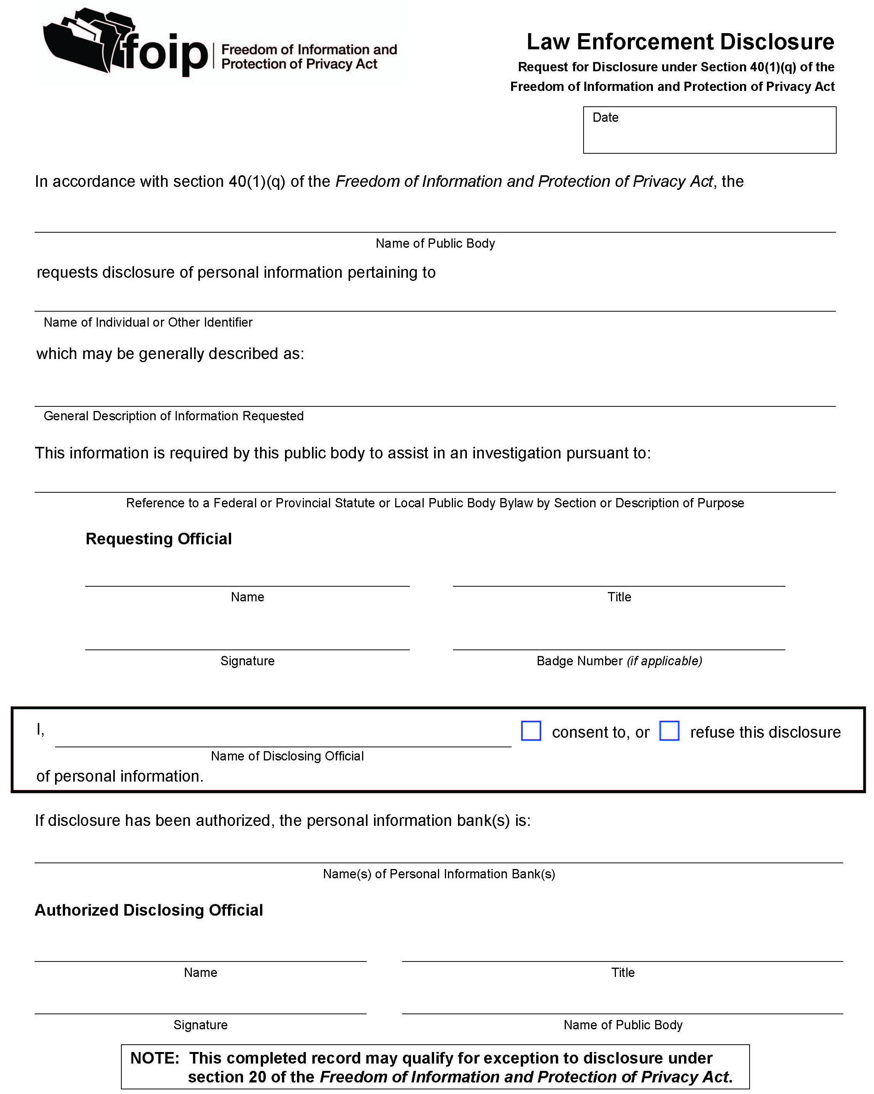
The information on this form is being collected pursuant to the Education Act and the Freedom of Information and Protection of Privacy Act. Questions concerning its collection or use can be directed to Rocky View Schools FOIP Coordinator, the Associate Superintendent of Business and Operations, by calling 403.945.4000 or by e-mail (busops@rockyview.ab.ca).

This information will be retained in accordance with Rocky View Schools procedures.

Reference:
- AP180 FOIP Requests for Access to Information or Correction of Personal Information

